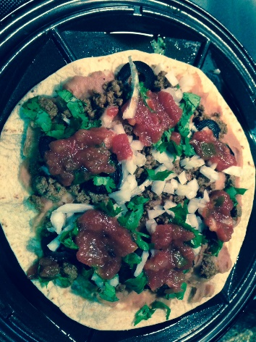
No Queso Quesadilla
Quesadilla before top tortilla added
- 2 Mi Mama’s Low Carb tortillas
- 1 oz ground turkey cooked with taco seasoning (I like to keep some on hand)
- 1/4 cup Old El Paso Fat-free Refried beans
- 1 slice of onion, chopped
- 3 springs of cilantro, chopped
- 2 black olives, sliced
- 2 TBSP medium salsa, mine is Kroger brand
Spray the quesadilla maker and warm it up. Spread the refried beans on one tortilla. Put the tortilla on the quesadilla maker and distribute the turkey on each section, so it doesn’t cover the ridges. Add the olives, cilantro, and onion. Dab on the salsa. Top with the second tortilla. Close the maker and let it cook until the ‘done’ light comes on – about 5 minutes. Move to a plate and cut into wedges. Enjoy.
Nutrition data from MyFitnessPal.com:
